
Department of CSE

B.Tech. CSE Trimester -5

2520030154
Pothuru Bhavana Manaswini

Cloud Infrastructure and Services
25CS2206E

LAB RECORD
2026

Experiment -1

AIM: To create an AWS free tier account to provision the resources.

Description:
Objective
To create an AWS account, complete the required verification procedures, and successfully access the AWS Management Console.
Prerequisites
- Valid email ID.
- Mobile phone number for OTP verification.
- Personal details (name and address).
- Internet connection.
- Payment method, requested by AWS:
  - Credit/Debit Card (Visa, Mastercard, RuPay or American Express).
  - UPI (where supported by the AWS India billing/payment process).
- AADHAR, PAN or another accepted identity document, if requested during AWS India customer verification.

Steps:
- Open the AWS Website. Open a web browser (Chrome/Edge recommended).
Go to: https://aws.amazon.com/free

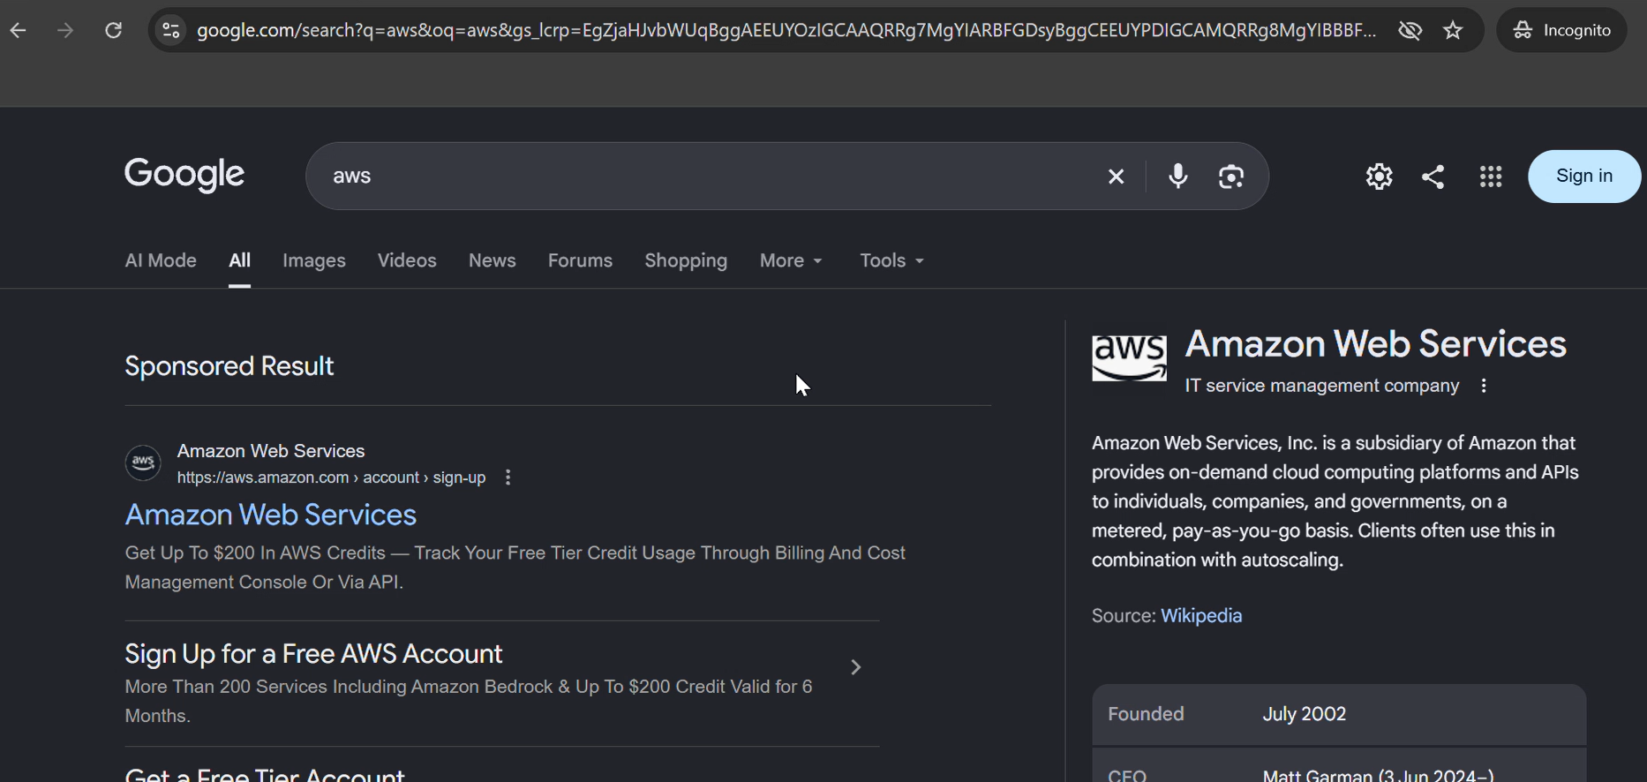
Now click on the link and the main site will open.

2. click on console
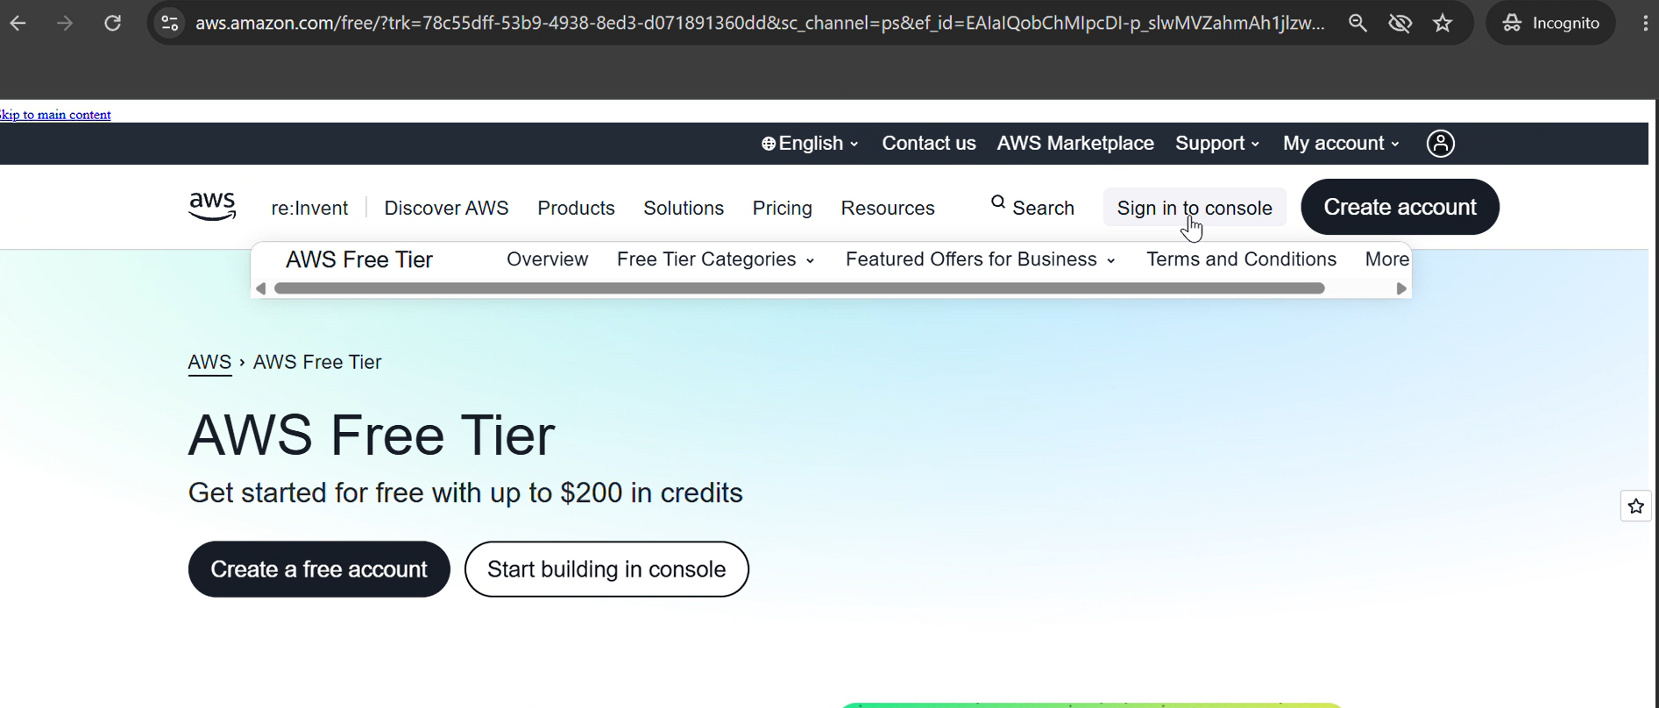

3. create a aws account
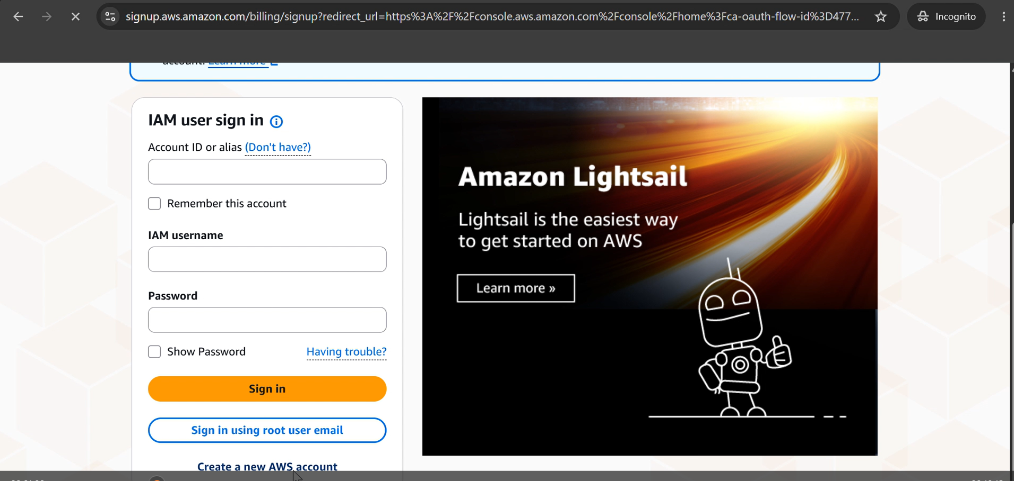
Enter the following details:
  - Email address
  - Password
  - AWS Account Name

4. Click Verify email address and enter the OTP sent to your email.
5. Choose your Account plan Free(6 months)-click Choose Free plan
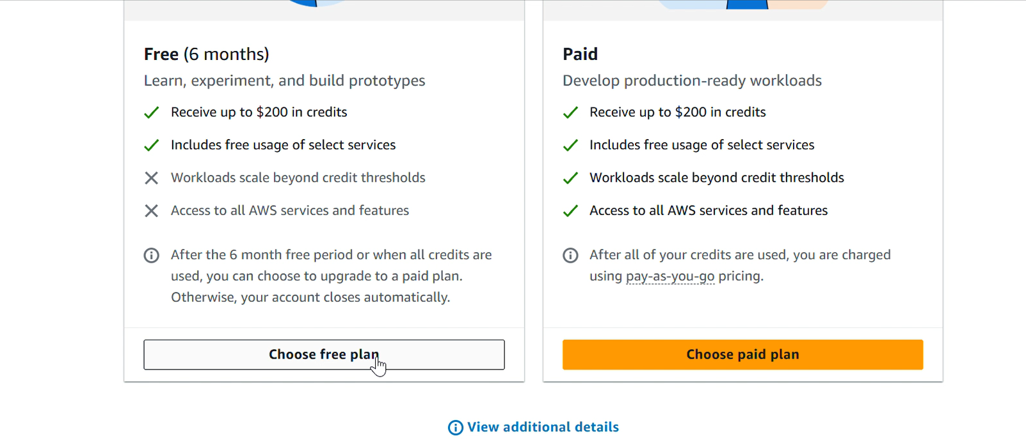
7. Give all contact information. Enter personal details:
  - Full name
  - Phone number
  - Address
  - City
  - State
Then proceed to next step
Choose UPI or credit/debit card option and accordingly give the details. If UPI (Automatic Payment limit 15000 should be there) just for authorization later autopay can be deleted later.

8. In the next step Confirm your Identity.
Choose primary purpose of Acount registration as Academic,
Ownership type as Individual
Document type as AADHAR…verification to be done through digilocker
Or voter id or driving license also can be provided….then click continue
- Provide Mobile number and click send SMS…..
Enter code for verification..continue.

Verification
- AWS Management Console dashboard is visible.
- The AWS account name is displayed in the account menu at the top-right corner.
- The account status and Free Plan information are accessible.
- You can access the AWS services available under your account plan.

Output:
A new AWS account is successfully created, verified and accessed through the AWS Management Console.

